**WEB API Interview Questions**

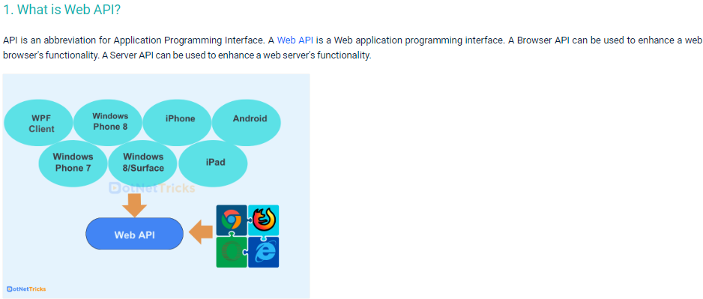

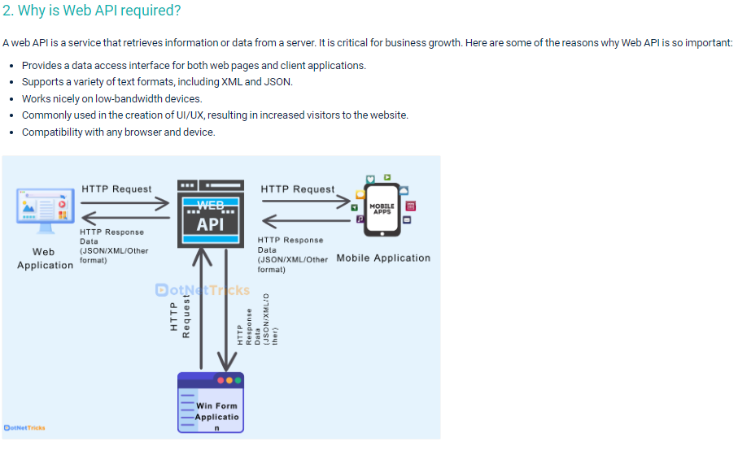

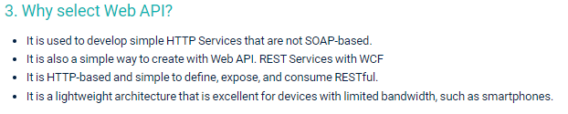

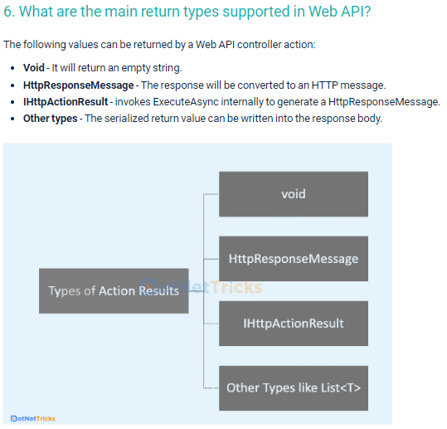

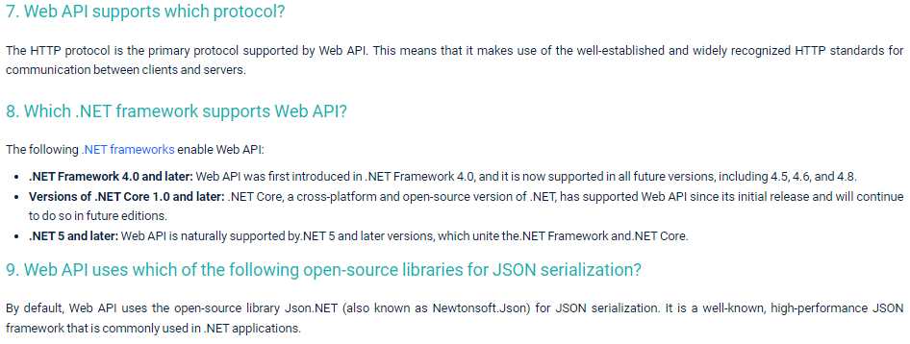

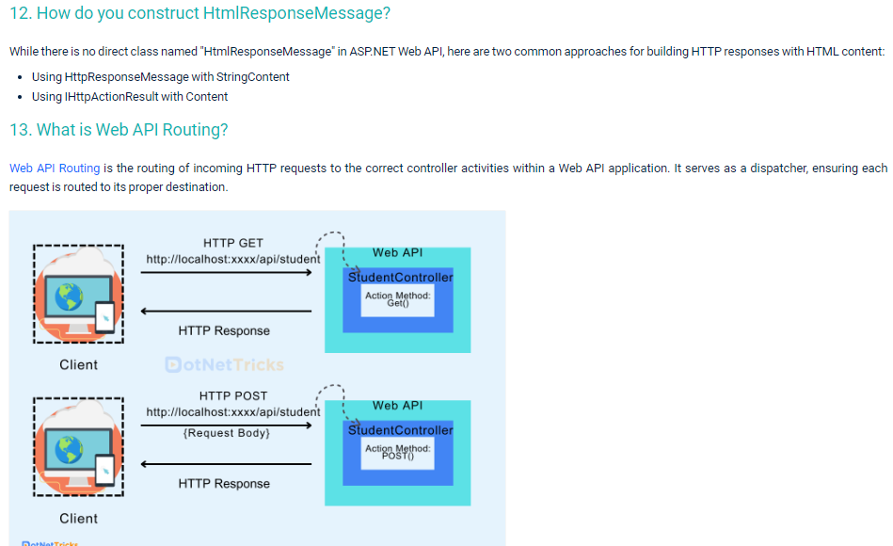

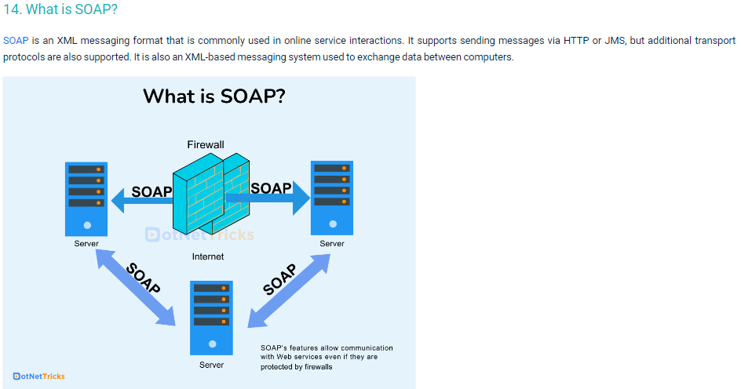

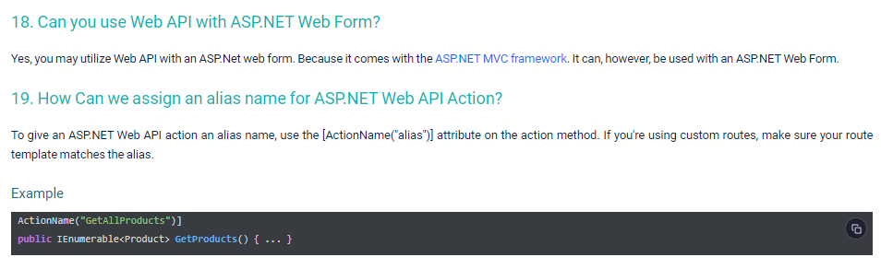

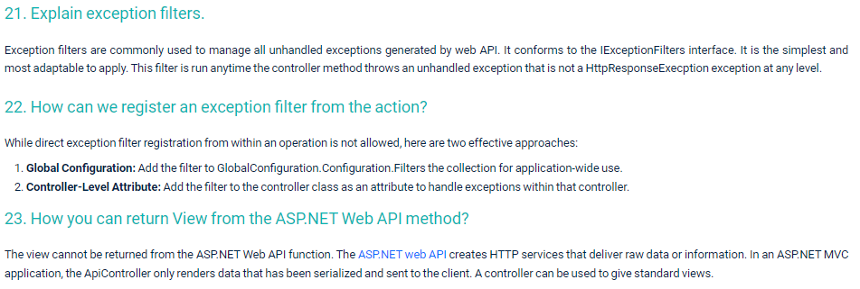

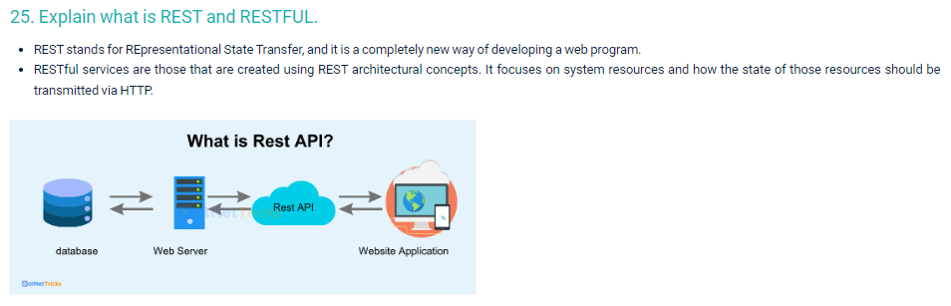

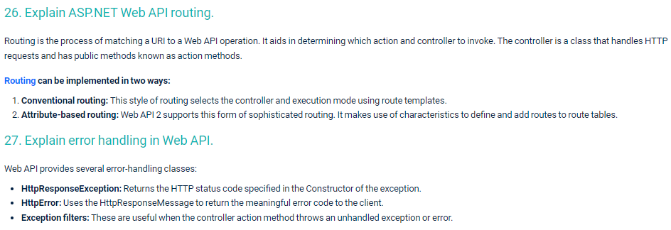

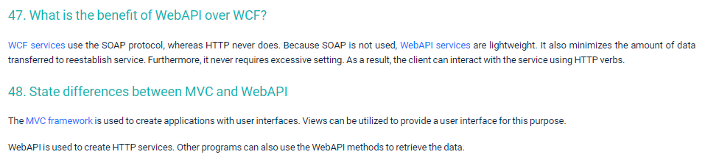

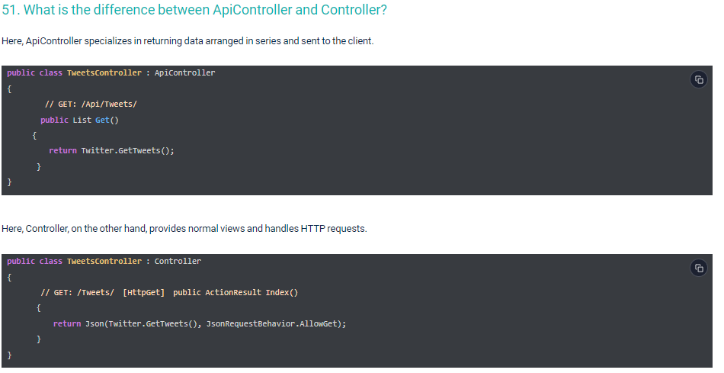

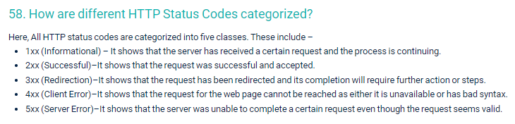

**API Versioning**

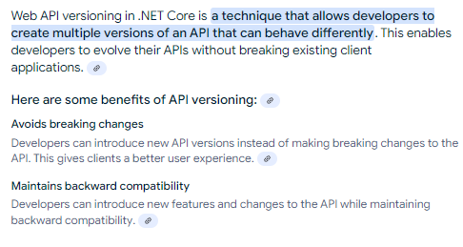

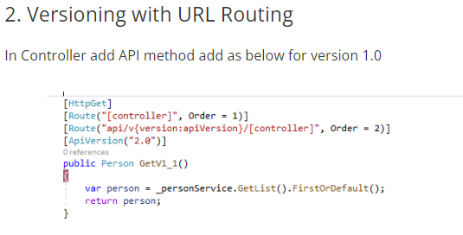

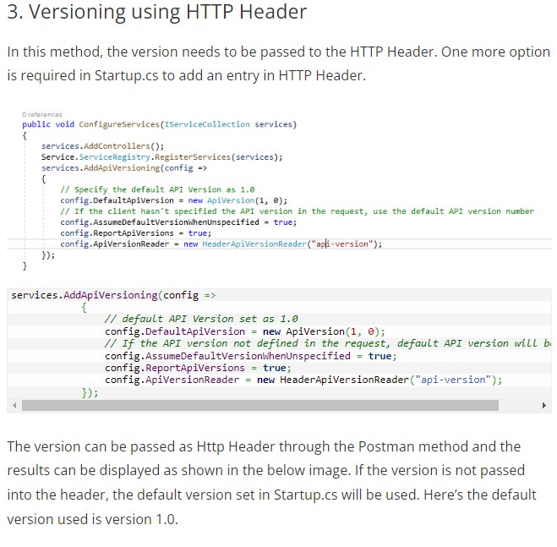

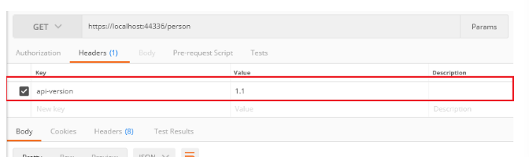

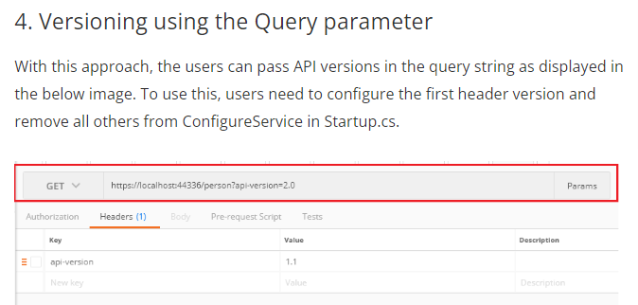

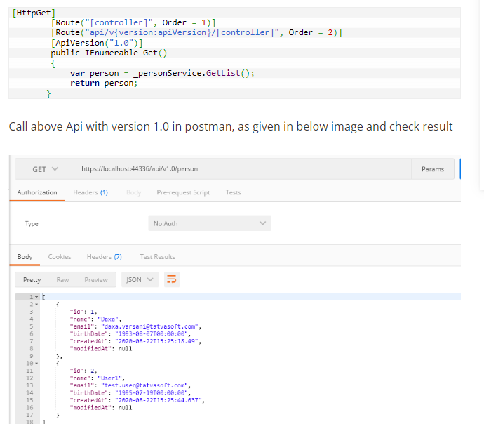

**Attribute based routing:**

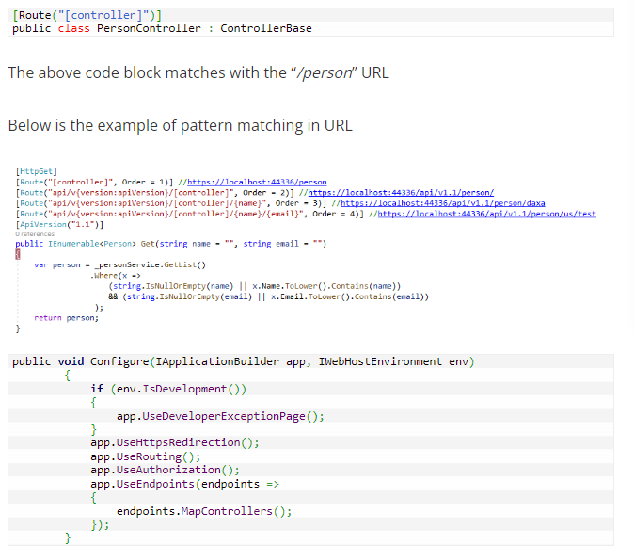

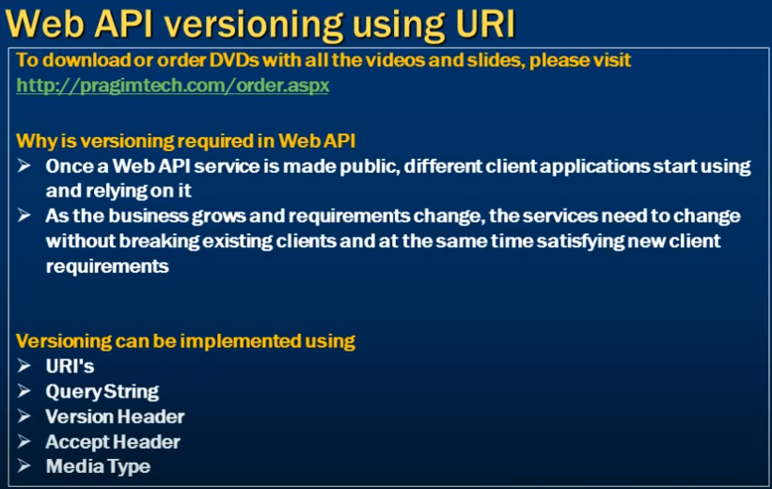

**What is attribute routing ?**

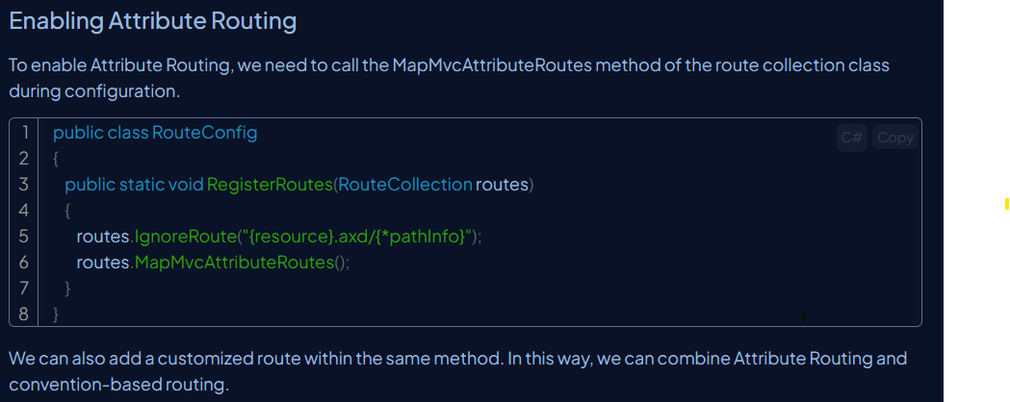

**Role of RoutePrefix attribute in web api**

Route prefixes are associated with routes by design in attribute routing.

It is used to set a common prefix for an entire controller.

**HttpPatch vs Put**

**Put –** Update a model and you need to send whole object for this. (Update all attributed replaced the whole resource)

**Patch – Just changing few attributes, it will update only requested properties in the model.**

